| Chennedy Software Corporation |
| --- |
| CheeseForce CRM Plan |
| Solution to MJ Logistics Gaming Company CRM Problem |
| Hao Chen  3-12-2025  [Version 1.0] |

Contents

A. Introduction 3

A1. Introduction and Purpose Statement 3

A2. Overview of the Problems 3

A3. Goals and Objectives 3

A4. Prerequisites 3

A5. Scope 3

A6. Environment 3

B. Requirements 4

Business Requirements 4

User Requirements 4

Functional Requirements 4

Non-Functional Requirements 4

C. Software Development Methodology 4

C1. Advantages and Disadvantages 4

Advantages of the Agile Method 4

Disadvantages of the Agile Method 4

Advantages of {A Different Method} 4

Disadvantages of {A Different Method} 4

C2. Best suited 5

D. Create Two Representations of the Software Solution 5

Representation 1 5

Representation 2 5

E. Testing 6

Test Name 1 6

Test Name 2 7

Test Name 3 8

F. Sources 8

# Introduction

# A1. Introduction and Purpose Statement

Chennedy Software Corporation is a long-standing software solutions company with a rich history dating back to the early 1900’s. From designing the first gas powered axle to the original Ford Model A to being the main chip designer for Nvidia’s long celebrated GTX 1080 series, Chennedy Software Corporation possesses a wealth of expertise across all fields of technology, from design to implementation. At Chennedy Software Corporation, we strive to provide excellent customer service as well as allow others to do the same for their customers by providing competitively priced software solutions to any clients and for any needs.

CheeseForce is the proposed solution to MJ Logistics Gaming Company’s problem of needing a new CRM system capable of keeping up with modern times. CheeseForce is a powerful CRM that excels at scalability, versatility, customization, and integration across multiple fields. CheeseForce is a cloud-based CRM that is designed to help a business centralize customer interactions, sales, marketing, and other service operations. It features ways to automate, track, and modify any steps of the business model, including but not limited to ticket tracking, sales, advertisement, and many more. CheeseForce is accessible anywhere due to its cloud-based architecture, and it is also AI-Powered with built in AI Model CheeseStein allowing for smart automation and predictive analytics.

The purpose of this document and Chennedy Software Corporation is to collaborate with MJ Logistics Gaming Company to implement CheeseForce while keeping the existing business processes as intact as possible, customize CheeseForce to fit the needs of a growing company, and lastly provide support even afterward integration to make sure all problems are solved in a timely matter.

# A2. Overview of the Problems

MJ Logistics Gaming Company is currently needing solutions to the following problems:

Outdated System – The current system is full of disconnected set of custom-built tools in various spreadsheet software, database management software, and other manual steps and processes. The tools are also all spread across many offices and employees who may even be working remotely. CheeseForce is a modern CRM platform and regarded as one of the most advanced ones used. It is regularly maintained and updated with its most recent version release being February 2025

Scalability – MJ Logistics Gaming Company is a rapidly growing company who’s been ranked 1 across many leaderboards in its field. With sales growing 42% in just too years, it needs a CRM system that can grow with it and handle high volumes of all aspects of sales. The old system is currently not set up to deal with these volumes of activity, and the processes are too slow because it is split up between many different software and employees. CheeseForce can scale with any business from start-ups to large corporations due to its Cloud-Based Architecture, allowing it to freely assign cloud-hosted computing resources based on demand and company needs.

Integration with Existing Systems – There are many existing systems within MJ Logistics Gaming Company that the company would prefer to keep around. Rather than rebuilding from scratch, MJ Logistics wants a solution that can easily integrate with existing systems so that transitioning is made easier and existing practices are able to remain. CheeseForce is extremely versatile, customizable, and able to integrate with many systems due to its API-Driven Architecture, which allows for easy and quick data exchanging with legacy and third-party systems and databases. Furthermore, CheeseForce supports bulk migration of data from legacy systems, making it easy to import data from MJ Logistic Gaming Company’s existing database over to CheeseForce’s new database.

# A3. Goals and Objectives

**Goals**

* Implement CheeseForce, a cloud-based CRM solution featuring many modern functions and capabilities
* Centralize all business operations to CheeseForce
* Improve and enhance security

**Objectives**

* Customize CheeseForce to handle both on-site and off-site user activities and access and set up roles across all layers
* Bulk migrate/import all existing data from legacy databases over to CheeseForce, removing the need to keep legacy data on legacy hardware and centralizing all data to CheeseForce’s cloud-based platform
* Setup security features, tracking features, and any other customizations needed for MJ Logistics Gaming Company to perform its functions
* Integrate CheeseForce with existing systems. Any systems not capable of integration will need to be rebuilt to be compatible with CheeseForce
* Provide training on the usage of CheeseForce
* Provide hosting via Cloud-based servers removing the need for physical storages

# A4. Prerequisites

List the prerequisites, their descriptions, and future completion dates. Be sure to be clear and concise for all listed prerequisites. (You may add lines for additional prerequisites if needed.)

| Number | Prerequisite | Description | Completion Date |
| --- | --- | --- | --- |
| 1 | Technical Demonstration | Chennedy Software Corporation will showcase features of CheeseForce it implemented for another client, highlighting all the features and addressing any questions or concerns MJ Logistics and Gaming Company may have | 5/1/2025 |
| 2 | Contract Drafting and Signing | MJ Logistics Gaming Company and Chennedy Software Corporation will come together and draft up a contract that both sides agree with outlining the costs, terms, conditions, and expectations of this project. Both sides must sign and be fully aware and fully knowledgeable about each other’s roles, jobs, and tasks in this project. There must be no confusion about any step of this process nor the costs. | 5/8/2025 |
| 3 | Systems and Hardware Assessment | Chennedy Software Corporation will send a highly qualified and experienced team to inspect and assess the current systems of MJ Logistic Gaming Company. The team will identify current system functions and take note of whether it can be integrated or not into CheeseForce. Any non-integrable systems or processes will be addressed and solutions/decisions to whether upgrade, remove, or rebuild these systems will be made during this time. A team from MJ Logistic should also be present to make sure Chennedy Software’s team is fully aware of the needs of MJ Logistics at all times. | 5/22/2025 |
|  |  |  |  |

# A5. Scope

Chennedy Software Corporation will implement and provide initial configurations to CheeseForce, taking note of any customizations that can be reasonably applied. Any requests that are impossible, excessive, or otherwise not outlined in the initial contract nor the initial assessment stage will be left up to the decision of the team leader Chennedy Software Corporation sends. CheeseForce will be the CRM that provides help and automation to manage sales, clients, reports, transactions, user access, and any other features outlined in the contract. Chennedy Software Corporation will provide in-depth training across the time span of 1 week to all employees of MJ Logistic Gaming Company that it sends. Chennedy Software Corporation will provide technical assistance related to CheeseForce until June 1st of 2026, but not to any requests that does not directly involve CheeseForce. After this period, Chennedy Software Corporation will only respond to requests and problems with the initial configuration of CheeseForce that it helped initialize.

Chennedy Software Corporation will only be responsible for the features listed in the contract. Any future customizations, modifications, or new features MJ Logistic decides to pursue will not be under the responsibility of Chennedy Software Corporation. CheeseForce will be hosted on CheeseForce Inc’s own cloud infrastructure, and as such, MJ Logistic Gaming Company will be responsible for signing, accepting, and paying for their own CheeseForce usage contract regarding prices of server hosting. Chennedy Software Corporation is strictly only responsible for setting up, training, integrating, and initializing CheeseForce for MJ Logistic Gaming Company.

# A6. Environment

The CheeseForce CRM will be hosted in a Cloud-Based environment that is provided by CheeseForce Inc, which claims to have 99.99% server uptime with scheduled periodic routine downtimes. CheeseForce also has different levels of SLA with Premier Success Plan providing access to 24/7 support for business-stopping issues and the Signature Success Plan provides the fastest 24/7 support response times for business-stopping issues.

CheeseForce does release periodic updates and upgrades every season that will not disrupt custom configurations. These updates are for the core CheeseForce platform, meaning that custom configurations and custom-built features will remain unaffected by updates.

CheeseForce CRM is one of the safest Cloud platforms using multi-layered security measures and encrypting data both at rest and in transit. Along with this, CheeseForce updates with routine security patches to ensure its systems are always up to date with the latest security measures.

CheeseForce is compatible and accessible with Edge Chromium, Google Chrome, Mozilla Firefox, Apple Safari for Windows, Android, and MacOS. For mobile devices, CheeseForce is compatible and accessible with Apple Safari and has a CheeseForce Mobile App that is available to download for both Apple and Android mobile devices.

# Requirements

This report will discuss the following requirements for the proposed CheeseForce CRM solution

* *Business Requirements*
* *User Requirements*
* *Function Requirements*
* *Non-functional Requirements*

## Business Requirements

CheeseForce CRM can fulfill MJ Logistic sales tracking and activity management requirements. CheeseForce centralizes all business data and processes into one single cloud-based platform. It is designed as a unified CRM system and can store data on stakeholder visits and meetings with any members of the company.

CheeseForce can integrate with MS Exchange and Outlook by utilizing the Outlook Integration plugin to view/log CheeseForce data direction within Outlook, Lightning Sync to facilitate contacts and calendar events with Microsoft Exchange, and Einstein Activity Capture to automate syncing of data between CheeseForce and email systems.

## User Requirements

CheeseForce is compatible with many browsers and OS. Because it is a cloud-hosted platform, interactions with the OS are minimal and it mainly is run via web browsers, of which most popular modern web browsers are supported. There is a mobile CheeseForce app available for mobile users.

MJ Logistic currently has 2000 users and 500 peak concurrent users that are forecasted to change and grow and scale. CheeseForce can easily scale with the user base due to its dynamic allocation of resources, allowing it to handle varying levels of activity.

## Functional Requirements

CheeseForce CRM has a powerful built-in ticketing system that allows it to handle MJ Logistic Ticketing System needs. CheeseForce Ticketing System automatically logs all customer interactions and tracks all communications. It provides a unique case ID for each ticket allowing for quick ticket identification and searching. All tickets will have details on the caller, recipient, details, dates, times and any further communications afterwards. Email replies can be automatically flagged and attached to appropriate tickets. Every action regarding a ticket is logged in an audit trail for compliance, ensuring full transparency in ticket handling and a historical record for future analysis.

## Non-Functional Requirements

The CheeseForce CRM will be hosted in a Cloud-Based environment that is provided by CheeseForce Inc, which claims to have 99.99% server uptime with scheduled periodic routine downtimes. CheeseForce also has different levels of SLA with Premier Success Plan providing access to 24/7 support for business-stopping issues and the Signature Success Plan provides the fastest 24/7 support response times for business-stopping issues.

CheeseForce does release periodic updates and upgrades every season that will not disrupt custom configurations. These updates are for the core CheeseForce platform, meaning that custom configurations and custom-built features will remain unaffected by updates.

CheeseForce CRM is one of the safest Cloud platforms using multi-layered security measures and encrypting data both at rest and in transit. Along with this, CheeseForce updates with routine security patches to ensure its systems are always up to date with the latest security measures

# Software Development Methodology

Examine the Agile methodology and compare it to other software development methodologies.

*Note: All subsections are required. Refer to the requirements section and rubric section of the assessment for additional information.*

# C1. Advantages and Disadvantages

## Advantages of the Agile Method

* Agile is fast because it does incremental development, which allows for smaller parts and features to be developed and tested while larger, complex, and more time-consuming parts are being developed. This results in fast deployments. For a scale of a project such as moving MJ Logistic to a whole new centralized system, speed is of the essence.
* Continuous feedback is given when using the Agile Methodology. Stakeholders and clients are free to share needs and feedback after every increment of development. MJ Logistic has many employees, users, and different groups that can provide different feedback based on their part of the project.
* High flexibility is a feature of agile methodology since changes to the project are easier to accommodate at all stages of development. New features or priorities can be changed or added without too much disruption. Because MJ Logistic used legacy system of many disjointed processes, being able to be flexible and work at different paces and different parts of the project is essential.

## Disadvantages of the Agile Method

* Scope creep can happen as feedback is continuously given and a lack of clear end goals are not provided. New features are constantly added and existing features changed and adjusted could lead to drastic increases in workload and delaying the project
* Fragmented output can happen when using Agile methodologies since the approach is iterative development, it is natural to have several features or parts of the project that are complete but cannot be put together yet. May lead to a very incohesive final product due to parts being completed independently at different times
* Less predictable outcomes is a side effect of Agile method. Due to the iterative nature of it and constant user and stakeholder feedback, it can be hard to set clear goals at certain times and it is often hard to predict when a feature is completed or the end date for the overall project

## Advantages of waterfall

* Clear structure and documentation are strong benefits of Waterfall methodology. Waterfall deals in linear and sequential development, so expectations and goals at each phase are well defined which leads to clear documentation and structured processes. This is due to the team all being on the same page working on the same part of the process. This could benefit this project because the initial scope of the project is large, and it is important the team is all on the same page at each stage of development.
* Client input is only obtained at the beginning of and at the end of the project. This minimalizes the impact of scope creep on the project. MJ Logistic is a big company with many clients, users, and employees. If everyone was always giving feedback, the project will end up being developed indefinitely.
* End goals are clearly defined at all phases. This makes it easy for both developers and stakeholders to be aware of and always have clear expectations of the project. Good for this project to make sure that everyone is aware of what is being worked on and what to deliver during each phase.

## Disadvantages of waterfall

* Lack of continuous feedback during the project can hinder the project. If mistakes or changes were needed to be made during the start of the project, it would not be made aware of until the end of that phase. This could potentially set back development time, since simple changes could potentially set back a whole phase.
* Late testing and discovery. Testing in Waterfall happens late in the process usually after development is completed. This can lead to major issues being only discovered after long periods of development time, making mistakes and fixes very costly and time-consuming.
* The delivery time of the project takes longer on average than Agile. Because each phase must be completed before moving on to the next phase in this sequential development model, different parts and phases cannot be worked on concurrently.

# C2. Best suited

Chennedy Software Corporation has made the decision that Agile Methodology would be best suited for this project.

The reason Chennedy Software Corporation supports using Agile Methodology for this project is because the project would require high flexibility at all points in time. The legacy system is full of independent and disjointed parts, and there is no reason to have to work on bringing each independent system over to CheeseForce one at a time. There are many parts of this project that can be worked on concurrently and have no need to wait on other parts before being tested. An example would be that transporting data from legacy data storages to CheeseForce can be worked on at the same time as initializing and setting up the new Cloud-based ticketing system and a different member can even work on email integration during this time frame. Each of these can be tested and worked on independently with minimal intrusion on the other parts of the project. Furthermore, we want to ensure that the project is always done with both employee and customer feedback. Because MJ Logistics has a vast customer and employee population, it is important that the new system makes the communications between the two seamless and enjoyable to use for both parties. Lastly, Agile is highly flexible with development and timeframes. A project of this scope along with the nature of integrating many independent processes to CheeseForce mandates that the development cycle be flexible with changes.

While Waterfall Methodology is a solid development method, we at Chennedy Software Corporation feel that a rigid, sequential development cycle would not be the best fit for this project. Time would be unnecessarily wasted waiting for developments of the current phase to finish when other parts of the project could be developed at the same time. Furthermore, only getting feedback at the beginning and end of the phase would mean that misalignment with user and employee needs are high and changes would have to push the entire phase back, wasting valuable development time.

# Create Two Representations of the Software Solution

*Note: You may add subsections here to fit the needs of the solution. At least two different representations of your design need to be present.*

## Representation 1

Below is an ERD of the CheeseForce Ticketing System. Each ticket will have only 1 caller who initiated the ticket. 1 Employee will be assigned a ticket, but employees are able to be assigned multiple tickets. At times, employees will have no tickets assigned to them. A ticket will have at least 1 log entry. Each change or update to the ticket will result in another audit log entry. Each audit log is associated with 1 specific ticket. Finally, each ticket will have an initial email associated with it. Email replies are linked to itself as replies. Each email will only have at most 1 reply and is a reply to at most 1 other email. A ticket can have multiple emails associated with it (Employee to caller, employee to manager, etc).

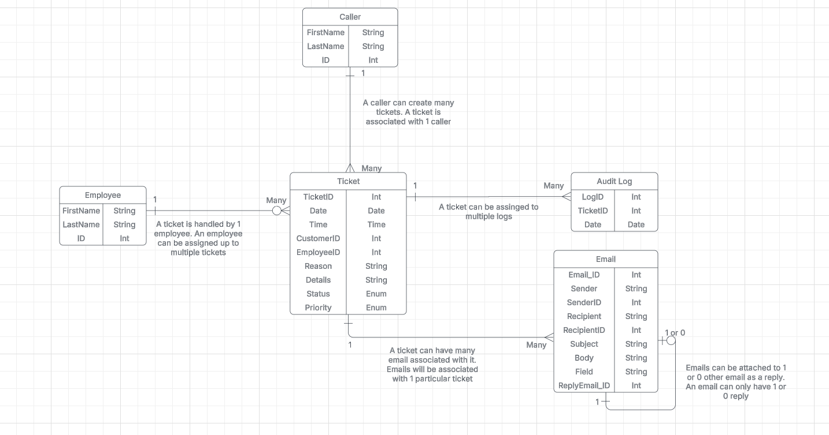

## Representation 2

Below is a flowchart showing a generalized simplistic front-end overview of how CheeseForce will handle customers and users logging in from its mobile application. Security logs, MFA, and other behind the scenes security checks are not included to avoid over complicating this flowchart.

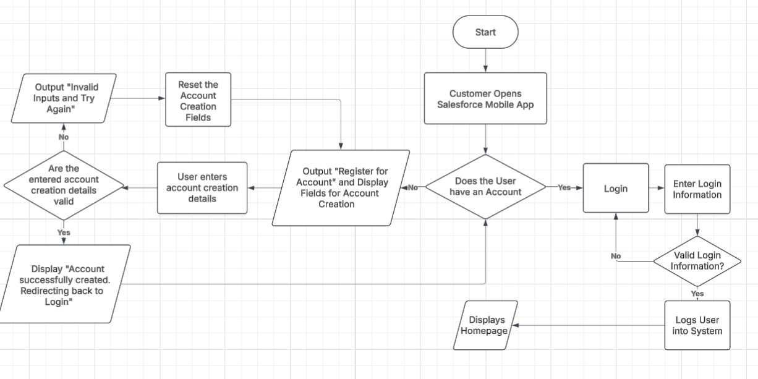

# Testing

# Test Name 1

| Requirement to be tested:  Ticketing Test for CheeseForce Ticketing System |
| --- |
| Preconditions: Conditions that must be present before the test case can successfully run.  CheeseForce must be successfully installed, setup, configured, and initialized. User accounts must be made for both employees and customer users. These accounts must be equipped with the necessary privileges, access, and roles, but not more than what is needed for their jobs/purpose. A sample size of various tickets with various problems and with varying levels of priority and statuses that imitate a real batch of tickets must be also drafted or provided. Goals and criteria for passing this test must be drafted. The system should be stable and not fail due to non-ticketing issues or any external influences outside the scope of this test. The team conducting the test must be familiar with CheeseForce, or at the minimum must be able to conduct their task for this test. |
| Steps: The steps the tester must execute to test the feature.   1. Create a new ticket with the relevant information including but not limited to, name, reason, priority, and user ID 2. Verify ticket is created, exists in database, contains an unique ticket ID, and all information related to the ticket is correct and accurate 3. Assign the ticket to an employee 4. Verify the ticket status is changed upon assignment, and that all employee-related features with the ticket is available (messaging, updating, responding, elevating) 5. Have the employee update the ticket to completed and close the ticket 6. Verify in audit logs all logs of the ticket from creation to closure is logged and in the database 7. Repeat steps 1-6 until all sample tickets are created and then completed |
| Expected results: Expected results and any side effects such as updating a database, writing to a file, etc.  The expected results are that each ticket from the sample size is able to be successfully created and assigned to an employee with all of its information intact and correct. Employees should be able to perform all its functions it needs according to each ticket such as emailing, replying, attaching more documents and email attachments, elevating, updating, and eventually closing the ticket as completed without any interruption or problems. The audit logs should have logged every single interaction and change for a ticket providing a clear trail to all activities associated with any given ticket. |
| Pass/Fail: Explain why the test case passed or failed. The results can be compiled and used to determine if the application is ready for delivery or release.  If all steps of the testing phase were able to be completed, no users encountered any problems while creating or handling tickets, ticket information were correct and accurate throughout the tests, and audit logs aren’t missing any information, then the test is a success.  If at any point a test step cannot be completed then it is a failure.  If at any point the ticket information is inconsistent, incorrect, or missing, it is a failure.  If the audit logs do not show or are missing logs on a ticket, it is a failure. |

# Test Name 2

| Requirement to be tested:  The importing/migration of data from legacy databases and storage to CheeseForce’s new database |
| --- |
| Preconditions: Conditions that must be present before the test case can successfully run.  CheeseForce must be successfully set up, installed, configured, stabilized, and initialized. The CheeseForce cloud database must be set up and ready for importing of new data. Internet connections must be available at all times, with Ethernet being recommended but WiFi also being acceptable. Legacy data must be in a digital form that is compatible to be imported to CheeseForce. For example, old transactions and data written out on paper must first be transcribed to a digitized form such as Excel.  All old data should then be exported to a database that can easily be exported into CheeseForce via sql scripts  CheeseForce database should have all necessary data fields created and ready and be compatible with importing via sql scripts  A sql script that imports old data and uses it to populate the corresponding fields of the new database. The script should compare the imported and exported datasets and return an error after each table if there are any differences. |
| Steps: The steps the tester must execute to test the feature.   1. Verify the legacy data is in a sql friendly format 2. Verify all the data is correct and ready to be imported 3. Run the sql script to import data table by table to CheeseForce’s database 4. Validate after EACH table populated that the data is successfully imported with no errors via sql script 5. Continue importing table by table 6. Manually validate the data tables |
| Expected results: Expected results and any side effects such as updating a database, writing to a file, etc.  Expected results should be the new database is populated with old data with no errors and fully operational.  Possible side effect is minor rounding of old data. For example, decimal fields in CheeseForce only go to 10^-10 for optimization of storage. Possible values in old databases that exceed that will be rounded. |
| Pass/Fail: Explain why the test case passed or failed. The results can be compiled and used to determine if the application is ready for delivery or release.  Pass if the scripts run with no errors and that the new database successfully contains all the data from the old set.  Fail if the database in CheeseForce is missing data or has incorrect data outside of expected differences such as rounding. |

# Test Name 3

| Requirement to be tested:  5000 Concurrent Users of CheeseForce |
| --- |
| Preconditions: Conditions that must be present before the test case can successfully run.  5000 user accounts must be created, available, and ready for use. JMeter must be set up and ready to use for monitoring the performance levels of CheeseForce. 50 high end computers with 64 GB of RAM must be available. These computers should be able to open and operate 100 tabs or instances of a browser at once. A script must be drafted to open a new Google Chrome tab, navigate to CheeseForce MJ Logistic Gaming Company site, read from a .csv file of usernames and passwords, input the username and password, and login before repeating the steps as they move down the .csv file of usernames and passwords.  CheeseForce must be installed, setup, initialized, and configured. A test environment for CheeseForce must be created and available for testing. |
| Steps: The steps the tester must execute to test the feature.   1. Verify CheeseForce test environment is live 2. Verify the performance monitoring tools are ready and set up (JMeter) 3. Verify all 50 computers are ready for testing 4. Open GoogleChrome on all computers 5. Run the script concurrently on all computers 6. Monitor the CheeseForce test environment and take notes of its activity levels, response time, resource allocation, etc |
| Expected results: Expected results and any side effects such as updating a database, writing to a file, etc.  The CheeseForce environment should be able to handle 5000 users at once and not crash at all during this. Each of the user accounts should have gotten acceptable response time from the server. Resource allocation should have scaled as more users were logging in to the platform. |
| Pass/Fail: Explain why the test case passed or failed. The results can be compiled and used to determine if the application is ready for delivery or release.  The test is a Pass if all 5000 user accounts were able to log in without the server crashing.  The test is a Fail if the server crashed at any moment during this test. |

# Sources

Place the sources that you used here.

*Note: See the sources section in the requirements and rubric. If you did not use any outside sources, you may delete this section.*